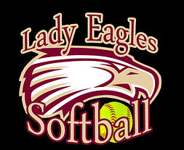

Anacorda 10 Foot Charging Cord Fundraiser Information Sheet
What you are selling:
* 10 foot, high quality, Apple certified charging cords.
* Cords come in assorted colors (cannot be specified) and are available for Apple iPhone, Micro, or Type-C. (see the cheat sheet to determine what cord is for what device)
* Cords are guaranteed to work.
* Apple iPhone cords sell for $15.00, Micro and Type-C are $10.00
* Each participant is expected to sell 10-15 cords.
* On the order sheet provided, each participant will fill out the customer’s information; products purchased, and collect all money or checks made out to Lady Eagles Softball at the time of sale.
* Fundraising sales window will be April 13th Through April 30th, with all order forms and moneys turned in by May 4th.
* You will deliver all cords by the end of May.
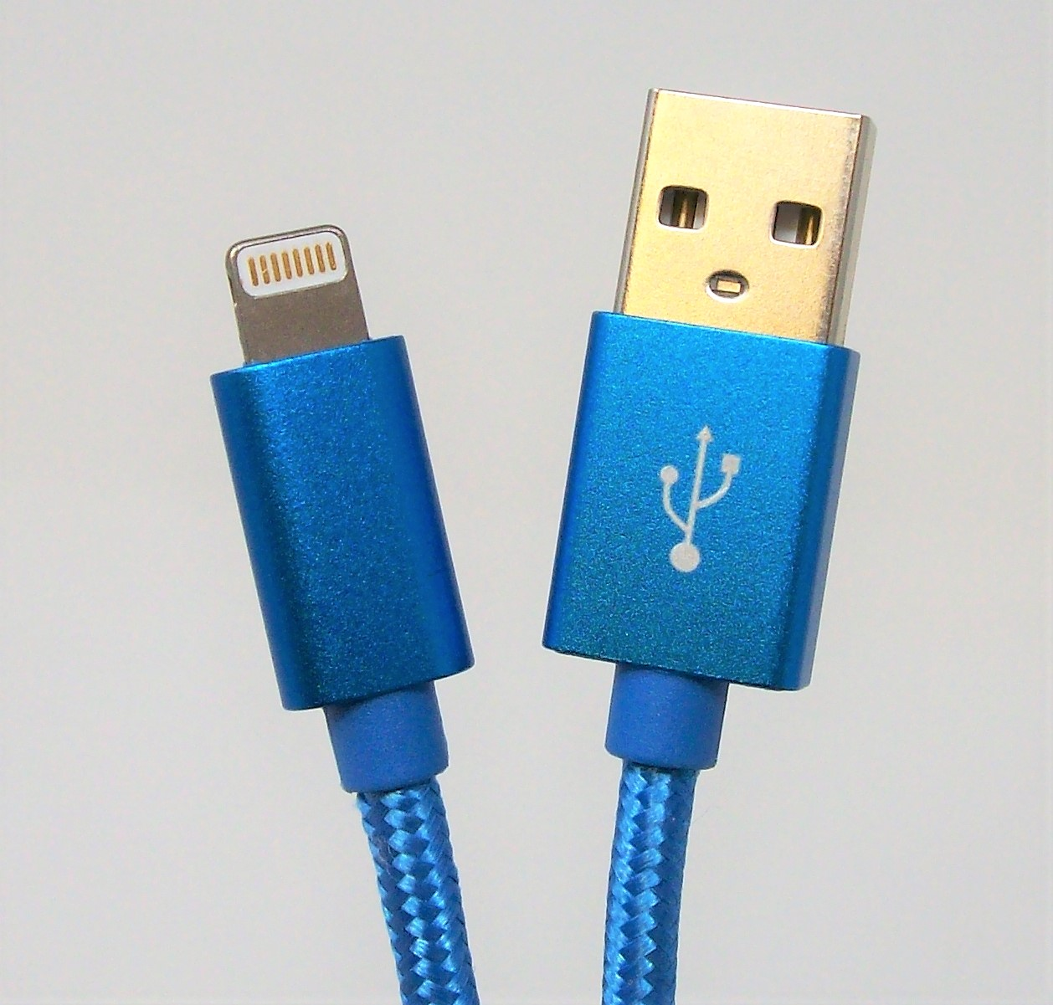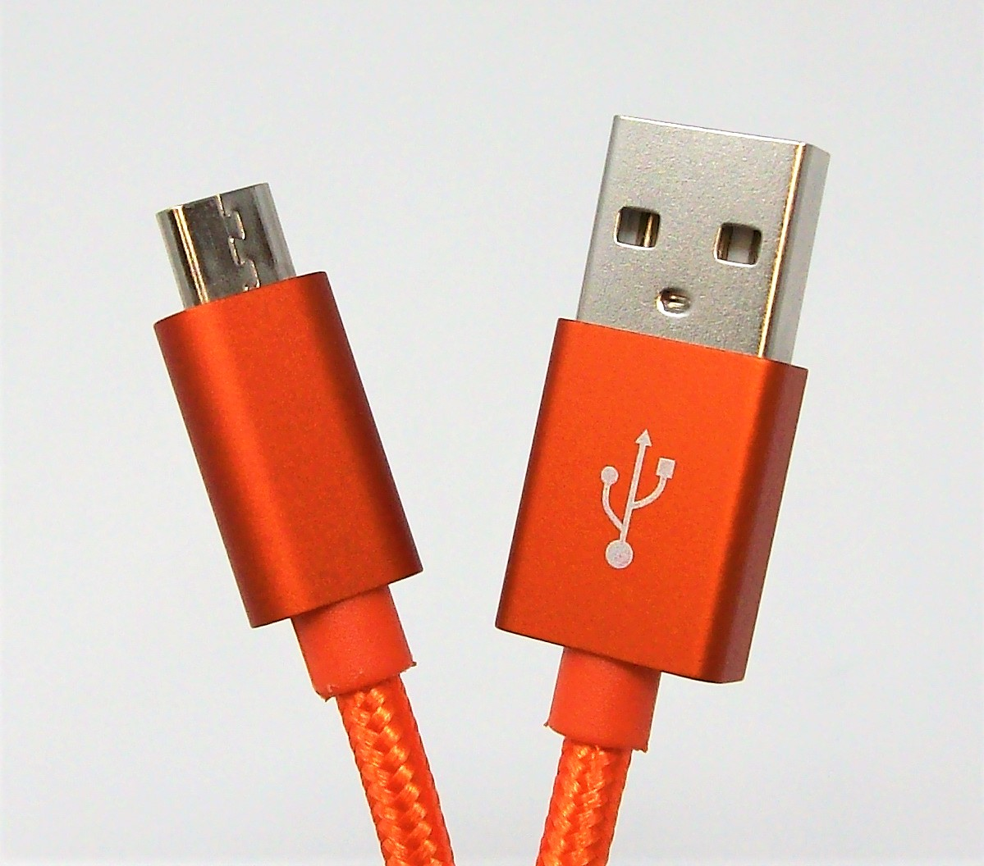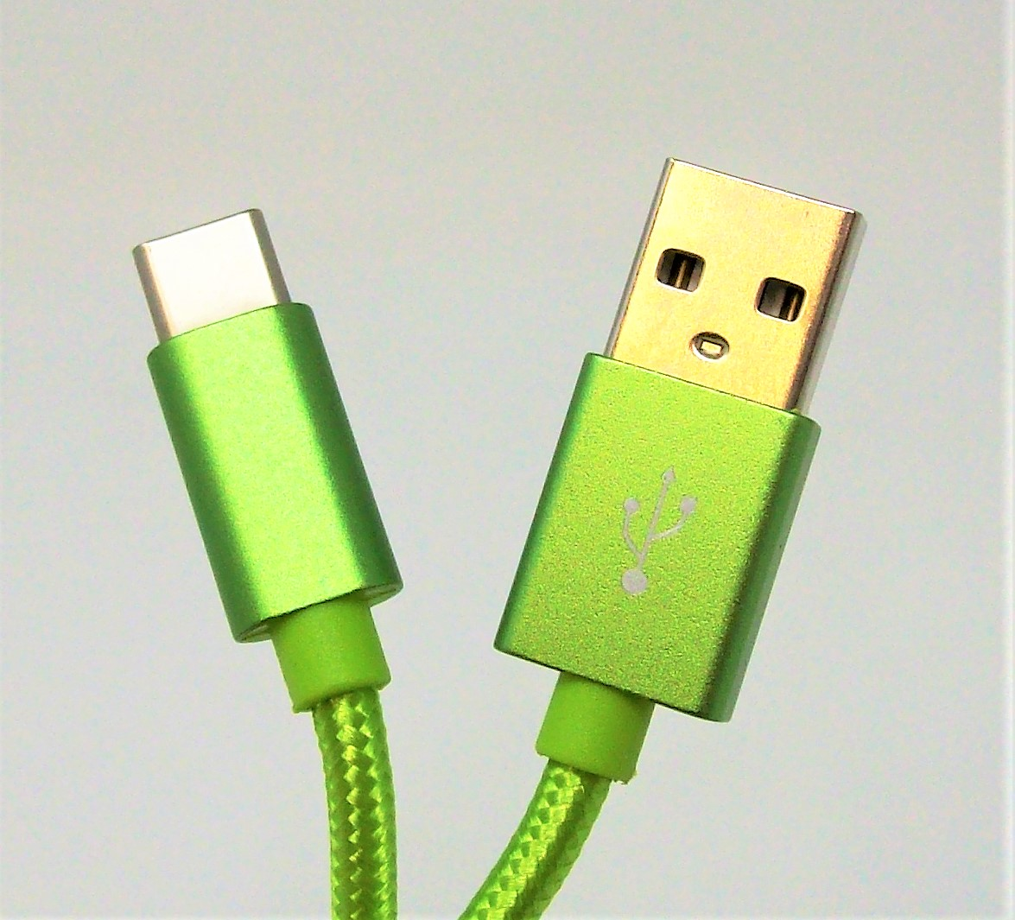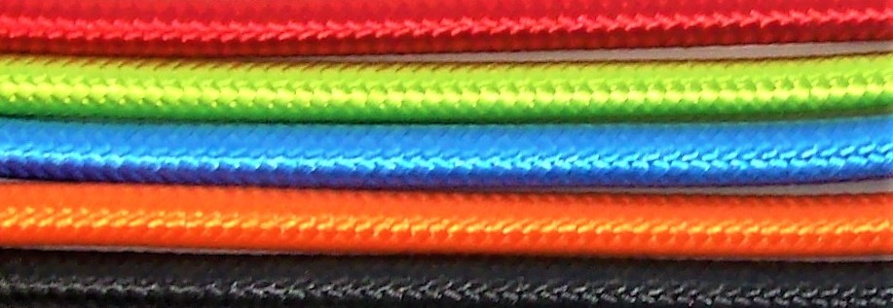

Contact info: D & D Enterprises
Dave Reed Jamestown, ND.
701-320-8935
www.ineedafundraiser.com

