

Beef Jerky Fundraiser Information Sheet
What you are selling:
* 80 count, re-sealable, 13 ounce jars of Beef and Pork Silver Dollar Jerky
* Four flavors to choose from: Old Fashioned, Teriyaki, Black Peppered, and Hot Gourmet. (Hot Gourmet is all beef)
*Shelf life after opened is about 30-45 days
* Each jar sells for $25.00 (Stores retail for almost $27.00!)
* Each participant is expected to sell 10-15 jars.
* On the order sheet provided, each participant will fill out the customer’s information; products purchased, and collect all money or checks made out to Lady Eagles Softball at the time of sale.
* Fundraising sales window will be April 13th Through April 30th, with all order forms and moneys turned in by May 4th.
* You will deliver all jerky by the end of May.
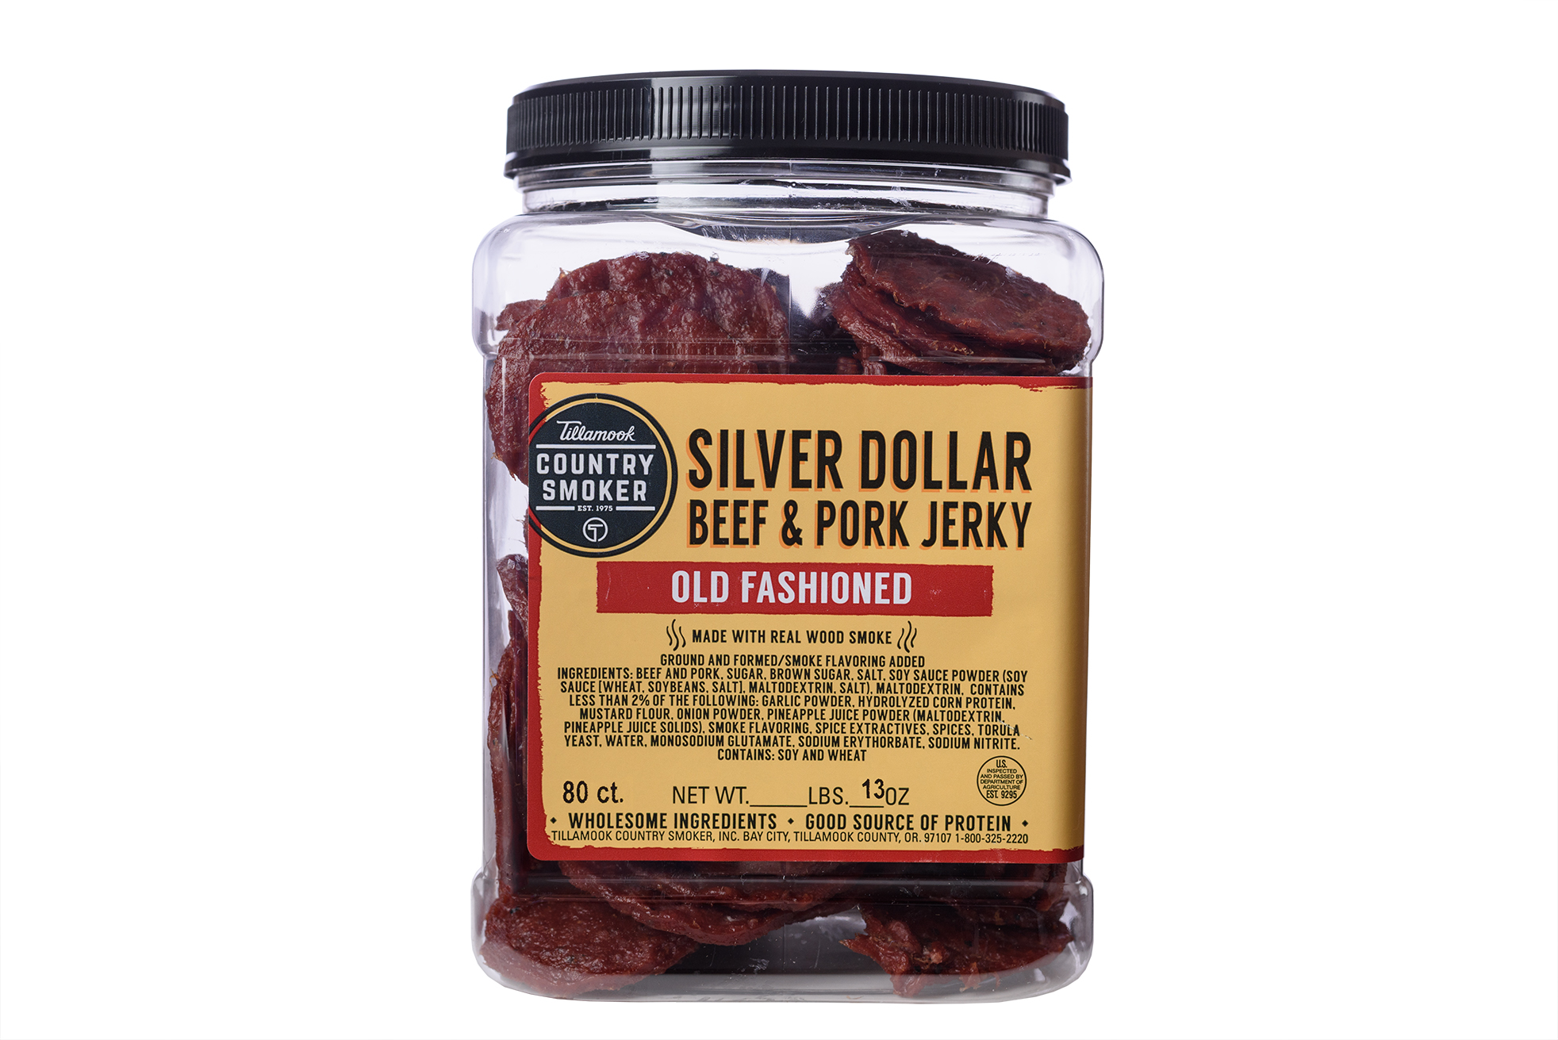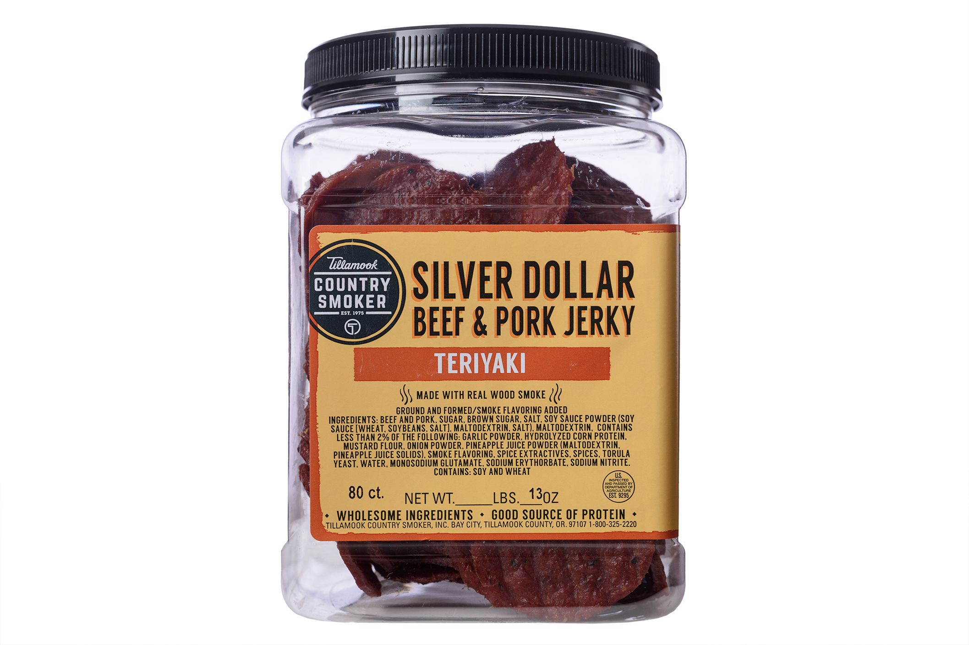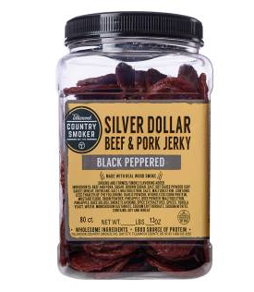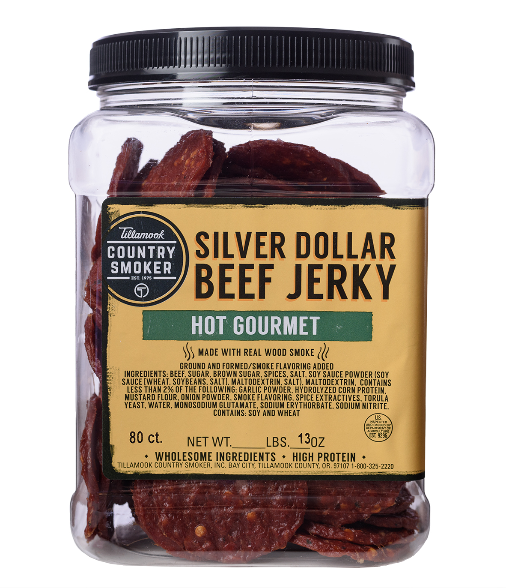

Contact info: D & D Enterprises
Dave Reed Jamestown / Fargo, ND.
701-320-8935
www.ineedafundraiser.com

